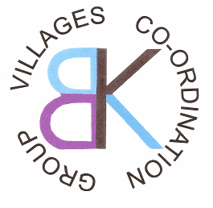

Micro-Grant Application Form

Blackwood & Kirkmuirhill Coordination Group
(Maximum Grant Available £500)

Contact Details:

Name of group or individual applying:

Main contact:

Address

Postcode

E-mail:

Telephone: (main)

Tell us about you and / or your organisation:

Are you a constituted group? Y / N

If you are not a constituted group, please explain who is involved in the group and what has brought you together?

Please provide details of your request – what activities will you carry out, who are the beneficiaries? How will the community benefit from an award?
How much are you requesting?

What will the micro grant be used to pay for? (Please provide a cost breakdown)

Declaration: I certify that the information contained in this application is correct, and that I am authorised to make the application on behalf of the above group / individual.

Name (please print):

Signature:

Date:

Please return completed applications to Blackwood & Kirkmuirhill Coordination Group

